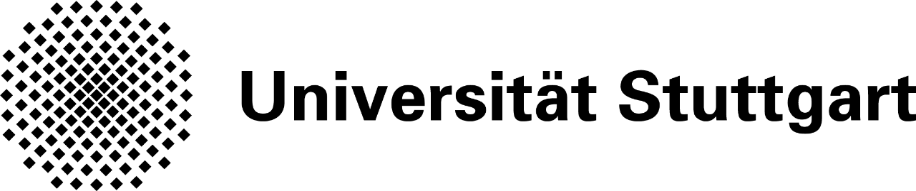

**Satellite Geodesy**

**“Klobuchar ionospheric correction”**

Lab-2

**Contents**

|  |  |  |  |
| --- | --- | --- | --- |
| 1. | Aim | | 3 |
| 2. | Introduction | | 3 |
| 3. | Objective | | 3 |
| 4. | Methodology | | 4 |
| 5. | Explanation: | |  |
|  | 1. | Computing satellite coordinates due to rotation effects | 5 |
|  | 2. | Calculation of angles | 6 |
|  | 3. | Klobuchar range-corrections | 6 |
|  | 4. | Vertical Total Electron content (VTEC) | 7 |
|  | 5. | Conclusion | 10 |
| 6. | Reference | | 10 |

**Aim**

To compute the Klobuchar range corrections for all the visible satellites and to make the time correction plots.

**Introduction**

Signals, on their path between satellites and ground stations, propagate through atmospheric regions of different nature and variable state, and thus experience different kinds of influences. Perturbations may occur to the direction of propagation, to the velocity of propagation and to the signal strength. Information on the state of the upper atmosphere can be obtained when the received satellite signals are compared with signals that would be observed under atmospheric free conditions.

A diagram indicating the number of ions produced as a function of heights shows a maximum in ion production rate. Such a diagram is called the Chapman Profile. The exact shape of the curve and related numerical values are depending on several parameters, and they are highly variable functions. Here, we are going to find those values for all visible satellites which should be found from the given sets of satellite data’s.

**Objective**

The main objectives of this lab are:

* Find all visible satellites to the observer.
* To get a good understanding of sky-plot of all visible satellites.
* Klobuchar range-corrections.
* Time-correction for all satellites

**Methodology**

**Explanation:**

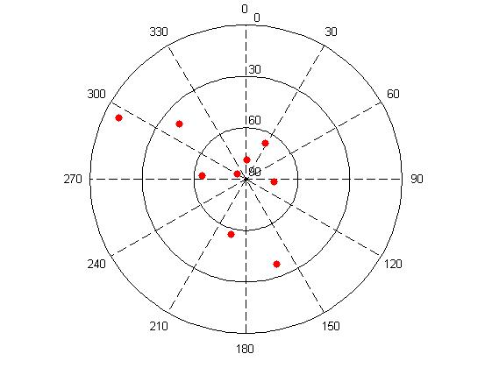

Fig. (1): Sky plot for the 9 visible satellites

1. **Computng satellite coordinates due to rotation effects**

The coordinates of the observer to receive the GPS Signal is given and these kinds of coordinates are global ellipsoidal and geographic coordinates *L ,B and H.*Also, the coordinates of different satellites are given in different epoch and these kinds of coordinates are spatial Cartesian coordinates.

It can be calculated by:

for i = 1:9

Ri = [cos(omega*t(i)) sin(omega*t(i)) 0; ...

sin(omega*t(i)) -cos(omega*t(i)) 0; ...

0 0 1];

xyzM = [x(9*(i-1)+1) x(9*(i-1)+2) x(9*(i-1)+3) x(9*(i-1)+4); ...

y(9*(i-1)+1) y(9*(i-1)+2) y(9*(i-1)+3) y(9*(i-1)+4); ...

z(9*(i-1)+1) z(9*(i-1)+2) z(9*(i-1)+3) z(9*(i-1)+4)];

xyzi = Ri*xyzM;

xyzt = [xyzt;xyzi];

end

xyzt = xyzt(4:end,:);

Pos_Rcv=(X0*ones(9,4)),(Y0*ones(9,4)),(Z0*ones(9,4));

Pos_SV=(xyzt(1:3:27,:)),(xyzt(2:3:27,:)),(xyzt(3:3:27,:));

1. **Calculate of the angles**

%%%% Length from satellites to the observer

S_RS = sqrt((xyzt(1:3:27,:)- X0*ones(9,4)).^2 + (xyzt(2:3:27,:)-Y0*ones(9,4)).^2 +(xyzt(3:3:27,:)-Z0*ones(9,4)).^2);

%%%% Length from satellites to the center of the earth

S_CS = sqrt((xyzt(1:3:27,:)- zeros(9,4)).^2 + (xyzt(2:3:27,:)-zeros(9,4)).^2 +(xyzt(3:3:27,:)-zeros(9,4)).^2);

%%%% Length from the observer to the center of the earth

S_OS = r*ones(9,4);

%% Calculate the angle

Angle_RS_RC = acos((S_RS.^2 + S_OS.^2 - S_CS.^2)./(2.*S_RS.*S_OS));

z = 180 - (Angle_RS_RC*180/pi);

zI = asin((r./(r + 1.0e6)).*sin(z));

azi=z*180/pi;

el=90-(Angle_RS_RC*180/pi);

a=z;

1. **Klobuchar range-corrections**

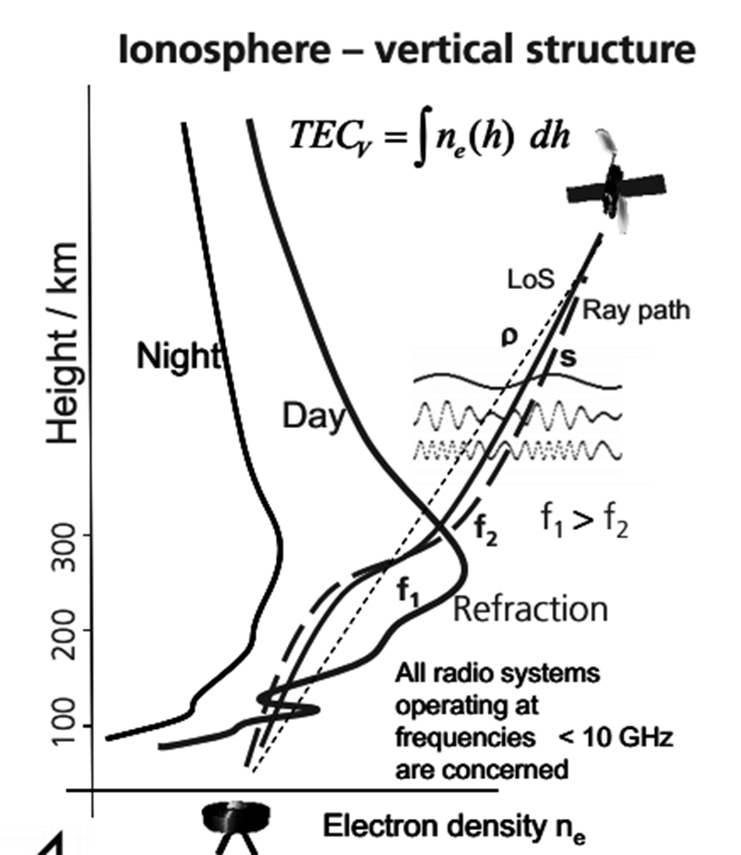

**Ref: http://www.icl-gnss.org/2012/Jakowski12.pdf**

GPS satellites broadcast the parameters of the Klobuchar ionospheric model for single frequency users. The Klobuchar model was designed to minimise user computational complexity and user computer storage as far as to keep a minimum number of coefficients to transmit on satellite-user link.

It can be calculated by:

psi = (0.0137 / (el(9,4) + 0.11)) - 0.022;

phi_1 = phi + (psi * cos(a));

lambda_1 = lambda + ((psi * sin(a)) / cos(phi));

phi_m = phi_1 + (0.064 * cos(lambda_1 - 1.617));

yy=2014;

mm=9;

dd=1;

hh_1=8;

hh_2=10;

tGPS = G2JD(yy,mm,dd,hh_1,0,0) - G2JD(yy,mm,dd,hh_2,0,0);

t_IPP = (43200 * lambda_1) + tGPS;

alpha_1 = 2.6534D-08;

alpha_2 = 2.2772D-09;

alpha_3 = -3.5174D-07;

alpha_4 = 5.1246D-07;

beta_1 = 1.4918D+05;

beta_2 = 8.4820D+04;

beta_3 = -1.5726D+06;

beta_4 = 4.0023D+06;

s_1 = (alpha_1 * phi_m) + (alpha_2 * phi_m) + (alpha_3 * phi_m) + (alpha_4 * phi_m);

s_2 = (beta_1 * phi_m) + (beta_2 * phi_m) + (beta_3 * phi_m) + (beta_4 * phi_m);

A_1 = max(0,s_1);

P_1 = max(72000,s_2);

X_1 = (2 * 3.14 * (t_IPP - 50400)) / P_1(9,4);

F = 1.0 + (16 * ((0.53 - el).^3));

if X_1 <= +1.57

dT_L1 = ((5 .* ((10).^(-9))) + (s_1 .* (1 - (((X_1).^2)/2) + (((X_1).^4)/24)))) .* F;

else

if X_1 <= -1.57

dT_L2 = ((5 .* ((10).^(-9))) + (s_1 .* (1 - (((X_1).^2)/2) + (((X_1).^4)/24)))) .* F;

else

dT_L3 = (5 * ((10).^(-9)))* F;

end

end

1. **Vertical Total Electron Content (VTEC)**

**epoch =epoch(1:9:81);**

f1 = 1575.42*1e+6; f2 = 1227.60*1e+6; T = 1/(40.3*(1/f1^2 - 1/f2^2));

%%TEC computation

TEC_S1 = T*S1;

TEC_S2 = T*S2;

TEC_S3 = T*S3;

TEC_S4 = T*S4;

TEC_S5 = T*S5;

TEC_S6 = T*S6;

TEC_S7 = T*S7;

TEC_S8 = T*S8;

TEC_S9 = T*S9;

%%VTEC computation

VTEC_S1 = TEC_S1.*cos(zI(1:81:9))

VTEC_S2 = TEC_S2.*cos(zI(2:81:9))

VTEC_S3 = TEC_S3.*cos(zI(3:81:9))

VTEC_S4 = TEC_S4.*cos(zI(4:81:9))

VTEC_S5 = TEC_S4.*cos(zI(5:81:9))

VTEC_S6 = TEC_S4.*cos(zI(6:81:9))

VTEC_S7 = TEC_S4.*cos(zI(7:81:9))

VTEC_S8 = TEC_S4.*cos(zI(8:81:9))

VTEC_S9 = TEC_S4.*cos(zI(9:81:9))

%%Plots

figure;

plot(epoch,S1,epoch,S2,epoch,S3,epoch,S4,epoch,S5,epoch,S6,epoch,S7,epoch,S8,epoch,S9);

xlabel('Epoch','Fontsize',14);

ylabel('P1','Fontsize',14);

title('P code','Fontsize',16);

legend('Sat 1','Sat 2','Sat 3','Sat 4','Sat 5','Sat 6','Sat 7','Sat 8','Sat 9');

figure;

plot(epoch,TEC_S1,epoch,TEC_S2,epoch,TEC_S3,epoch,TEC_S4,epoch,TEC_S5,epoch,TEC_S6,epoch,TEC_S7,epoch,TEC_S8,epoch,TEC_S9);

xlabel('Epoch','Fontsize',14);

ylabel('TEC','Fontsize',14);

title('TEC','Fontsize',16);

legend('Sat 1','Sat 2','Sat 3','Sat 4');

figure;

plot(epoch,VTEC_S1,epoch,VTEC_S2,epoch,VTEC_S3,epoch,VTEC_S4,epoch,VTEC_S5,epoch,VTEC_S6,epoch,VTEC_S7,epoch,VTEC_S8,epoch,VTEC_S9,epoch,VTEC,epoch,VTEC_average);

xlabel('Epoch','Fontsize',14);

ylabel('VTEC','Fontsize',14);

title('VTEC','Fontsize',16);

legend('Sat 1','Sat 2','Sat 3','Sat 4','VTEC','V-a');

for i=1:size(azi,1),

svx(i)=el(i)*cos(a(i));

svy(i)=el(i)*sin(a(i)); %Calculate polar co-ordinates

end

polarhg([30 60]) %Prerequisite script used to format axis

hold on

plot( svx,svy,'.r','markers',20); %Plot satellite location

hold off

%% Format output

for i=1:el,

text(svx(i)+7,svy(i),num2str(prn(i)), 'FontSize' ,10) ; %Add PRN labels to each point

end

axis('square')

grid on;

set(gcf, 'Color', 'w'); %Change background of figure from grey to white

ti = get(gca,'TightInset') ; %Remove extra spacing around figure

set(gca, 'LooseInset', [0,0,0,0.01]); %Depending on the figure, you may need to add extra spacing [left bottom width height])

print( '-dtiff', ['skyPlot'], '-r600'); %Change "-r600" to the required DPI

Fig. – (3): VTEC for the 9 visible satellites

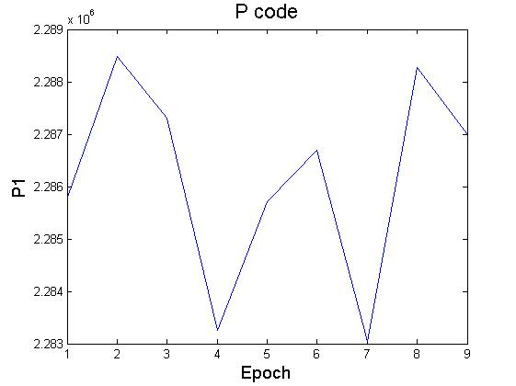

Fig. – (4): P codes for the 9 visible satellites

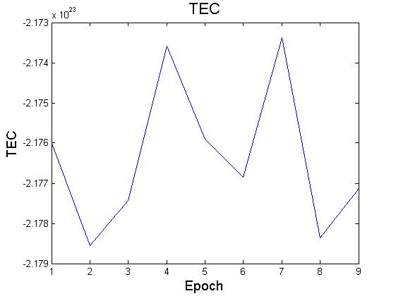

Fig. – (5): TEC for the 9 visible satellites

**Conclusion**

There are 9 visible satellites for the observer. The impact of the state of the ionosphere on the propagation of waves is characterized by the Total Electron Content of these satellites in the varying epochs.

**Reference**

1. Guenter Seeber- Satellite Geodesy – 2nd edition
2. wikipedia
3. <http://www.gmat.unsw.edu.au/snap/gps/gps_survey/chap5/532.htm>
4. <http://www.navipedia.net/index.php/Klobuchar_Ionospheric_Model>
5. <http://www.icl-gnss.org/2012/Jakowski12.pdf>